|  |
| --- |
| **UCSI COLLEGE** |
|  |
| **ACADEMIC YEAR 2023/2024** |

**Subject** **:** **DATABASE DESIGN CONCEPTS**

**Semester** **:** **MAY 2023**

**Programme** **: Diploma in Information Technology and Diploma in Information Systems**

**ASSIGNMENT COVER PAGE**

Course Details

Subject Code : DIT 2034

Subject Title :DATABASE DESIGN CONCEPTS

Trimester                    : MAY 2023

Title of assignment     : Delivery System of the Uber

Lecturer’s Name : Miss Lee Chiw Yi

*Important Note* *: Submission of assignments is the responsibility of the students.*

***Failure to reference may result in a zero mark***

Student’s Details

1.  Name and ID : WONG KIAN SENG - 2022000351 (DIS)

2.  Name and ID : CHEN FU JIAN - 2022000163 (DIT)

3.  Name and ID : CHEW ZHUN GUAN - 2022000343 (DIT)

4.  Name and ID : LIEW ZHI JIAN - 2022000038 (DIS)

**1.0 Introduction**

Society have generalized database approach, as it is proven to be the most superior way to keep track of data and information, but have you ever wondered why database in general is such an efficient management tool? Database by itself is just a collection of logically related data that are managed by Database Management System also known as “DBMS”. Every application that we know most definitely have a database that stores all the user’s information, and those application’s system can be categorized into multiple group such as E-commerce System, Management System, and even Delivery System. Although it seems daunting at first, as information related to database are not exactly a common knowledge, with our simple explanation we hope it may help it easier to grasp it.

**1.1 Uber**

Uber, also formerly known as Ubercab is a popular delivery system / delivery management software (DMS) application that is well-known among the ride-hailing and delivery industry especially for western countries. Over the years, Uber had been through a lot of changes and improvements, although there were some ups and down, but they never gave up and earn the place as one of the most popular ride-hailing and delivery service in the world.

Uber is an application/ service that posses many sub-branches such as UberEats, UberX, UberX share, Uber comfort, Drive and deliver with uber, and Uber Freight. In order to dominate the delivery industry, Uber had adapted and changed over the years, and all those sub-branches was the result of their adaptation. On one hand, UberEats is a “Restaurant Food Delivery” where they use the delivery system to access the database for information such as the recipient’s address, recipient’s contact information, and transaction information.

On the other hand, UberX, UberX share, Uber comfort, Drive and deliver with uber, and Uber Freight are roughly same thing but with their own niches and specialties. UberX, UberX share, and Uber comfort are ride-hailing services that uses delivery system to access database for information related to the users such as name and their destination. In contrast, Drive and deliver with uber are services for the driver, which uses the delivery system to access database for the driver’s information and keeping track of their performances while still providing the driver’s relevant information related to the user such as the destination. Lastly, Uber Freight is an application that allow expert drivers to ship goods from suppliers to their destination, which provide the suppliers a more flexible and fast option for deliveries.

As for Uber’s history, it was not as smooth sailing as one would interpret, as uber had a lot of issue in their uprising. Uber was founded by Garett Camp and Travis Kalanick, and the idea of Uber was originally just a random conversation topic about “What if you could request a ride from your phone”. However, that Garett Camp took an interest in that idea and bought the domain name UberCab.com, and that was how everything started.

In 2009, Garett Camp began working on a prototype of UberCab, which soon went into the testing phase in early 2010. The app also launched publicly in San Francisco in May of the same year, which quickly blew up and got them their first major funding by First Round Capital. It was also in the same year that UberCab officially shorten their name into Uber, however it was also the same year that Uber got their first cease and desist by the San Francisco Metro Transit Authority & Public Utilities Commission of California. Around April of 2015, Uber most popular and well-received sub-branch was launched, and it was known as UberEats which till this day is still the most used sub-branch of Uber. Surprisingly in July 2015, Uber became the most valuable startup in the world, with the value of $51 billion after its funding rounds. The net value of Uber only kept rising even thou they had some hiccups such as the loss of China business.

In spite of Uber’s success in terms of net value growth, Uber will get a taste of their worse year yet. In 2017, Uber was hit with several charges one of them being sexual harassment in the workplace. Besides that, the CEO of Uber Travis Kalanick was caught fighting with an Uber driver, which at the time cause an uproar of negative responses. In addition, Travis Kalanick was also sued by an early Uber investor for fraud in the same year, which perhaps may had caused the resignation of Travis Kalanick. Allegedly, Uber had a cyberattack that exposed 57 million people’s personal data, but till this day that cyberattack have not been denied or confirmed by Uber. Despite all those dramas, Uber did not lose much in terms of net value, however Uber’s reputation had pummel due to those drama. As for 2018 till present, not much has happened due to Covid-19 pandemic most of Uber’s services for a while, but the pandemic also made UberEats revenue skyrocket as it was the only ways for many restaurants to function and families to order food when the lockdown happened. As for the future of Uber, we can only wait and see what they do from now on.

**1.2 Compare and Contrast**

*(i) Uber VS Grab*

|  |  |
| --- | --- |
| Similarities | Differences |
| Both platforms provide cash or cashless payment feature | Grab mainly operates in the Southeast Asia while Uber operates from all around the world (globally) |
| Both Grab and Uber have e-wallet services where users can top up the amount using payment methods such as debit/credit card. | Uber charges their customers based on the distance and time which they are travelling to. However, Grab tells their customers a specific and fixed amount before travelling from one location to another. |
| Offers various services such as Taxi hailing services, food and package delivery | Grab is originally from Malaysia while Uber is from the Unites States |

***Figure 1.0***

*(ii)Uber Vs McDelivery*

|  |  |
| --- | --- |
| Similarities | Differences |
| Both platform offers food delivering services | Uber mainly operates as a Taxi hailing service; it also offers various services such as package delivering services and many others. However, Mcdelivery only does food delivering services. |
| Offers cash or cashless contact payment | Uber provides multiple choice from various restaurants to users when it comes to ordering food while McDelivery only allows users to order food only from their store. |
| Both companies frequently give out coupons or promo codes to customers to make meals more affordable for customers. Hence, increasing brand loyalty. | McDelivery charges a fixed amount for its delivery fees while Uber charges its delivery fees based on the user’s location and demand during that time. |

***Figure 1.1***

*(iii) Uber Vs FedEx*

|  |  |
| --- | --- |
| Similarities | Differences |
| Both platform offers delivery services | Uber only delivers packages locally around the country while FedEx delivers packages from all over the world globally. |
| Allow users to rate services which collects user’s ratings and opinion to see what they can do better so they can improve user’s experience to attract more customers and hence increasing their sales. | Uber cannot deliver packages exceeding a certain amount of weight while FedEx can deliver packages with heavy weights and from overseas. |
| Both companies provide real time tracking feature to allow user to monitor of when their packages will arrive. | Uber utilizes their own workers and also their own vehicle while FedEx has a centralized logistics with their pre-owned vehicle for their employees to use to deliver packages. |

***Figure 1.2***

*(iv) Uber Vs AirAsia SuperApp*

|  |  |
| --- | --- |
| Similarities | Differences |
| Both platform offers Taxi-hailing services | Uber has car rental services which AirAsia SuperApp doesn’t offer. |
| Supports contact and contactless payment | AirAsia SuperApp contains loyalty programs where rewards, discounts, and other special incentives are given to users as a way for the company to retain its existing customers and also to attract new customers. Uber does not have loyalty programs. |
| Allow users to pre-book their ride | Uber App is known for booking rides to allow customer to travel from one place to another within the country itself while AirAsia SuperApp is mainly used for booking a flight where customers travel from one country to another. |

***Figure 1.3***

**1.3 Function of the Uber**

*1.Uber eat*

=The application will suggest food and beverages based on the customer’s personal preferences, based on their order history and most recent order.

-store user order history.

-store a variety of food and beverages.

-keep track of the restaurants that are suitable for the user area and time.

- based on user’s order history and most recent order suggest.

food and beverage that are suitable the users.

*2. Uber Connect*

= The application will save the locations that have been set by the user

for their future orders.

-store the users location.

-store users deliver history.

*3.Rating/Review*

=User will be able leave review which will allow other user to make

better decision.

- store the rating that have been rated by customer.

*4. Uber Pass*

= Users are able to register for membership, which will store the user’s personal

information for future uses and as a reference for verification.

- store user’s personal information.

*5. Personal Accounts Management*

= Users able to store their personal information, such as contact number,

bank account, home address for future uses.

- store user’s personal information.

*6. Trip Details*

= The application will store the previous driver's information after the users/

customer have reached their destination for safety purposes.

- store user’s trip details such as route, destination and

the time of arrival and departure, and driver’s account information.

*7 Activities / History*

= Users are able to save their bank account information in the application,

which allow users to make transaction easier.

- store user’s bank account information.

*8.Uber wallet*

= The application will store the previous order, receipt, and trips in the history

as evidence, report, or memo after the task/order been completed.

- store user’s order, receipt, and trips

- store driver’s completed task/orders

*9. Uber rent*

= Users can rent a variety of transport including cars, electric scooters, bicycles, and others while the application stores the current user and the previous renter’s information

- Checks database for transportation that are still available and provide user’s the require information to rent the said transportation such as the location of the vehicle, the amount of time it can be rented, the current condition of the vehicle, and provide the contact information of the vehicle owner.

- Store the previous renter’s information such as contact number and name for

the vehicle owner.

*10. Carpool (Uberpool)*

= Users are allowed to share the car with other users while the application manages the operation.

- Store data of drivers that sign up for UberX, as driver has the option to not sign up for it.

- Store and gather driver's performance and completed task as a UberX driver, which would be compiled and organized into categories to allow the driver to perform in their best condition.

- Assign the proper amount of customer/user to the driver based on the data and information in the database that was inputted by the driver. For example, their vehicle capacity and the vehicle maximum weight capacity.

*11. Scheduling a ride (UberX)*

= Users are able to schedule a private ride at a specific time and specific location

- Stores the designated location and routes for customers

- Drivers are able to accept scheduled rides for customers

- The database keeps track of each scheduled rides for both customers and drivers which allow the driver able to maintain schedules and routine easier

****1.4Target Audience**

***Figure 2.0***

According to research on the Internet, we had collected information about the target audience of Uber. Based on what we found, Uber is a company that is trying to attract people that do not own a car, do not like to drive, or want to travel in style with an affordable and cost-efficient cab. Therefore, Uber offers a variety of categories of services, such as Mobility as a Service, food delivery, and Freight transport. Additionally, each category of services has its own differences and target audience.

Through these 3 types of categories, introducing Mobility as a Service, or as what we call it as Uber Taxi. Uber Taxi is a service that allows a user to call a cab through Uber’s mobile application which sends signals to nearby drivers about the customer’s location and where he/she wants to go. On top of that, Uber also offers another service called the UberX share, where the riders can carpool with another rider to reduce the cost of service. With these two services, we can clearly see that that there are two different types of Uber target audience in this category, which includes the user and drivers. According to our research, it is found that Uber’s target market for rider is between 16 to 65 years old with highest 31 percent for age range from 16 to 24 and lowest age range from 50 to 65, which includes both males and females. Moreover, there are also 27% of Uber Taxi’s users in the US which are classified as the top 25% income earners (usually those who works for Uber’s premium service, such as Uber Black), 44% of users are middle-income range (those who work for Uber Rent and Uber Green), and 22% of users are in the low-income range (more for UberX Share). According to the data that we had collected from Uber, the diversity that Uber has created such as Uber Green, UberX share, and Uber Black is to cater to the different needs and demands of the public. For instance, people who earn a higher income can choose Uber Black to enjoy the premium service which allows them to experience the luxury vehicle service with a convenient, yet equally glamorous ride. Moreover, middle-income range’s users can enjoy services like Uber Green which connect riders with hybrid and fully electric vehicles, or they can use UberX Share; another economical choice for riders to choose from which they will have carpool with other riders to cut cost and enjoy a low-cost ride.

Aside from that, Uber’s primary reason to create Uber’s driver is to attract its main target audience like people who wants to have a flexible work hour, want to earn extra income on the side, or are looking for a full-time job as a Uber’s driver. According to the demographic segmentation of Uber, it is found that 4 to 5 million of Uber drivers worldwide in 2023, are usually older as based on the data found, there are only 6 % of Uber’s drivers that are under the age of 30, and on average the other drivers are between the age of 30 – 49. Other than that, we also found out that, there are only 27% of Uber’s drivers are female. Apart from that, Uber also offers a range of services for drivers that can help them choose the type of driving experience that works best for their needs and preferences. As an illustration, driver can choose to be a driver of UberX, UberXL (allow drivers to transport larger group of passengers, usually up to six person), UberX share, UberBlack, UberSELECT (driver need to meet Uber’s premium vehicle requirement to be eligible for this service), and UberEATS (food delivery service). Overall, drivers are crucial for any delivery system, such as Uber, Grab and Food Panda. Also, there is no income and meaning if there is lack of driver in a delivery system. As a result, drivers are a type of target audience for Uber, and they correspond to each other.

Following that, we will now introduce the second category, which is regarding on the meal delivery. The target audience of the food delivery of Uber includes a wide range of people who are looking for convenient and reliable food and delivery services. In this category, Uber furnishes a type of service called UberEATS. UberEATS is a service that delivers food to the customer’s doorstep by using its mobile application. The inside of UberEATS application includes many types of cuisine and different restaurants that users may not acknowledge, it also allows users to schedule a food delivery in advance, and comment about the restaurant (food quality) or driver (how fast is the delivery). According to our research, the data indicated that Uber Eat annually has gain up to 85 million of users in 2022 and the average user’s age is from 18 to 65, which 25 – 34 years old has up to 35% with the highest proportion and the range of 65 years old and above has only 3.8 % with the lowest proportion. With this data, it is indicated that, the reason of why 25 -34 years old range will be the highest proportion is because that, the people in this age range usually will work up until late night and forgot to have dinner, so they decided to order food from delivery system and enjoy the food while they still in the middle of work. In opposite, the reason why the age range for 65 years old and above will be the lowest proportion is because that, the people in the group are not exposed to using electronic devices. To sum up, UberEATS is an essential for a part of Uber as the demand of UberEATS can help bring Uber a substantial income.

Lastly, moving on to the third targeted audience which is Uber freight transport. In case you weren’t aware, Uber Freight is a logistic and transportation platform that is designed for shippers and carries to connect and move freight efficiently. The target audience of freight transportation has 2 types of target audiences, which are shippers and receivers. Shipper is the person that is the primary target audience for Uber’s Freight shipper platform, these may include manufacturers, wholesalers, distributors, and retailers that need to deliver goods from one location to another in a cost-efficient way. While the receiver is the person who will collect the goods from the sender. According to the Uber Freight’s data, there is a similarly between sender and receiver as the age group of the Uber Freight is between 25 - 55 and 43.8% of the audience are in the age range of 34 – 44. Subsequently, 31.6% in the age range of 25 – 34 and for the age range from 45 to 54 accounted for 24.6%. Not only that, the graph also show that there are 59.6% sender and receiver are woman and 40.4% are male. Through this data and information, we can analyze out that, women are the one who typically browse for items from the e-commerce store, such as Lazada, Shopee and Carousell

**1.5 Data/Information collected from the application**

*(a) Search Bar*

= Stores the user's most recent searches into the database and displays those data in the most recent search section.

*(b) Review/FAQ*

= Stores user's review and questions into database, which would be responded by Uber's customer service later.

*(c) Account/User Profile*

= Stores newly registered user's account information such as ID, password and email, which allow the user to logins and use the application.

*(d) User's recent ride history*

= Uber's application poses a notable feature that securely maintains records from a user's recent ride history within its database management system (DBMS). This functionality serves as a valuable resource and evidences for both the users and Uber itself.

*(e) Driver information*

=The Uber application includes a dedicated section within its DBMS to store comprehensive driver information, including details such as driver ratings, car plate numbers, compliment, names, and experiences. This information is crucial for Uber to provide a smooth and reliable service to its users. Additionally, Uber offers a user-friendly graphical user interface (GUI) that allows users to access and review this information once they have placed an order. and are awaiting their assigned driver.

*(f) Trackers*

= This feature really comes in handy especially when a user feels unsafe inside an Uber ride, which means it acts a safety emergency function where user are allowed to share its live location to his/her close friends and family so that they can see if the user have reach their designated location and can prepare if they feel something fishy is going on. With the help of this feature, they can quickly share the whereabout information (unique address) of the user to the police department so that they can quickly act on to save one's life.

*(g) Cookies*

= Uber uses cookies to build a file on your Uber and related activities. Uber uses cookies for various reasons such as for Personalization and Preferences purposes and Advertising and Remarketing which both reasons collect's and analyse users information and in return helping Uber to generate more sales as they understand their customers well.

**2.1 DESCRIPTION**

|  |  |
| --- | --- |
| **Name of Member** | **Parts that in charge** |
| 1. WONG KIAN SENG | Question 2 – Driver Management  **&**  Question 3 – Relation 1 - 4 |
| 2. CHEN FU JIAN | Question 2 – Registration  **&**  Question 3 – Relation 5 – 8 |
| 3. LIEW ZHI JIAN | Question 2 – Purchasing and Payment  **&**  Question 3 – Relation 9 – 12 |
| 4. CHEW ZHUN GUAN | Question 2 – Admin and Reporting  **&**  Question 3 – Relation 13 - 16 |

**2.2 THREE (3) Similar / Related Database Application Systems**

1. Driver Management

**Uber**

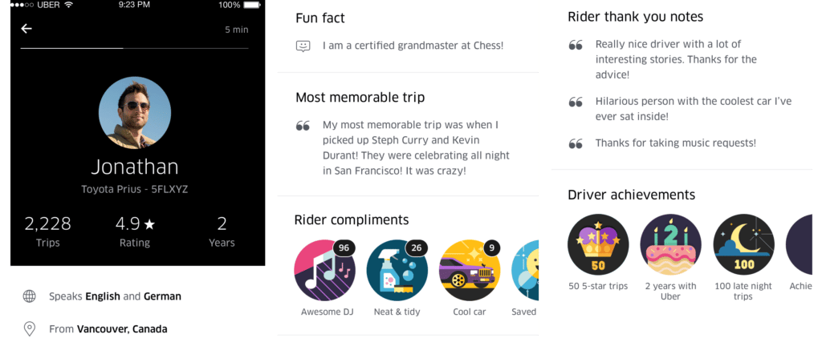

**Figure 3.0**

The picture above shows how Uber manage driver’s information and present it on the driver’s profile page to allow users to understand more about the driver’s personality and behaviour based on comments and ratings by users.

**Lyft**

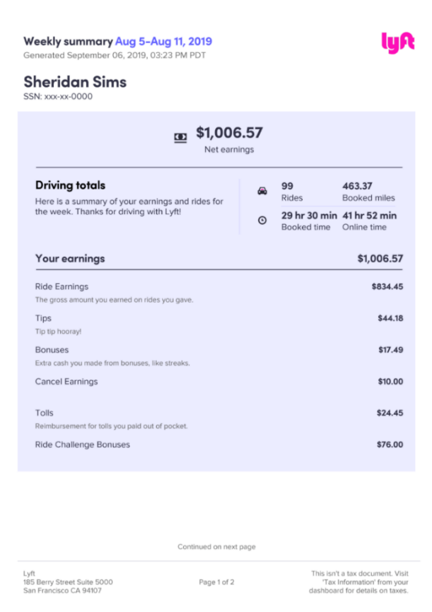

**Figure 3.1**

This picture shows how Lyft helps to keep track of driver’s income forecast, reports, and analytical data as it helps to identify trends and patterns of the current market.

**Grab**

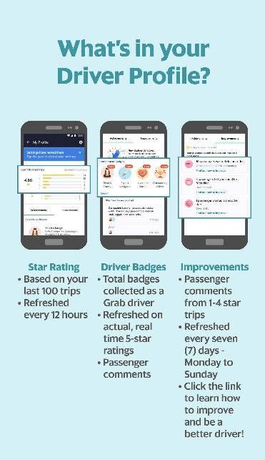

**Figure 3.2**

Grab company collects user ratings and opinions involves gathering feedback and subjective evaluations from users regarding their experiences, satisfaction levels, or preferences after every ride as to let driver’s get a better understanding on the needs of users in the present-day market.

**Food Panda**

**Figure 3.3**

The image presents how the Food Panda driver app show rider the designated location of where to pick up customer’s food and where to send it. After the food is delivered to the customer, riders will earn a specific amount of commission from the company.

1. Registration

**Uber**

**Figure 3.4**

Uber work similarly with Grab, offering various type of services. However, Uber company mainly operates in the United States while Grab mostly operates in the Southeast Asia.

**Lyft**

**Figure 3.5**

Create your account in minutes with Lyft, unlocking access to a network of reliable drivers who are ready to whisk you away to your destination.

**Grab**

***Figure 3.6***

Grab company provides a vast array of services such as transport, food or buying necessities. It all can be done just by using the Grab application.

**Food Panda**

**

***Figure 3.7***

Signing up for Food Panda is quick and easy, granting you access to a vast selection of restaurants and cuisines. you can browse menus, read reviews, track your delivery, and enjoy the convenience of doorstep service.

1. Purchasing and Payment

**Uber**

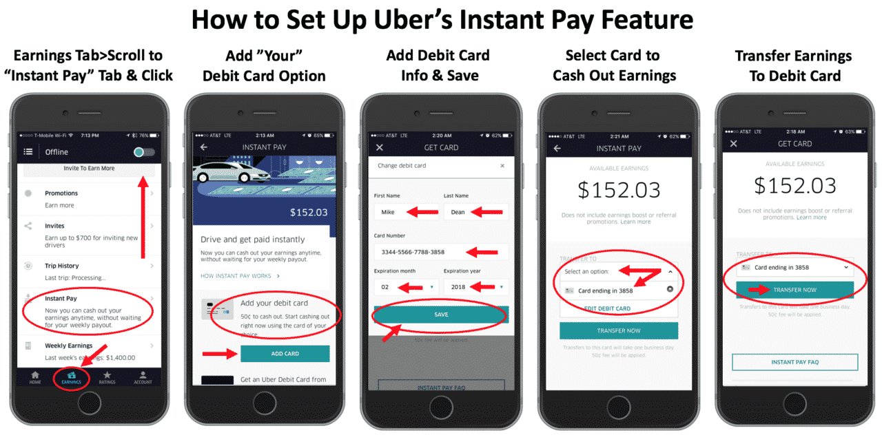

***Figure 3.8***

Uber offers a variety of payment methods to its users to select from, for the services it provides such as Transportation and Food Services. The image above shows how a user sets up his/her debit card information in the app so he/she can use it to pay for a particular service fast and more conveniently in the future.

**Lyft**

***Figure 3.9***

The picture shown above shows that Lyft provides various payment methods before the ride such as using cash, credit card or debit card. If user chose cash, then he/she will need to pay directly to the driver after a ride however if he/she chose to use debit or credit card then at the end of the ride, the amount charged will be directly credited from the user’s bank account.

**Grab**

**Grab**

***Figure 3.10***

Grab works the same as Uber, providing various payment options for users to choose from.

**Food Panda**

***Figure 3.11***

With Food Panda allows users to enjoy the convenience of simple payments and accurate invoicing information, by providing different payment methods and order summary of users.

1. Admin and reporting (Driver)

**Uber**

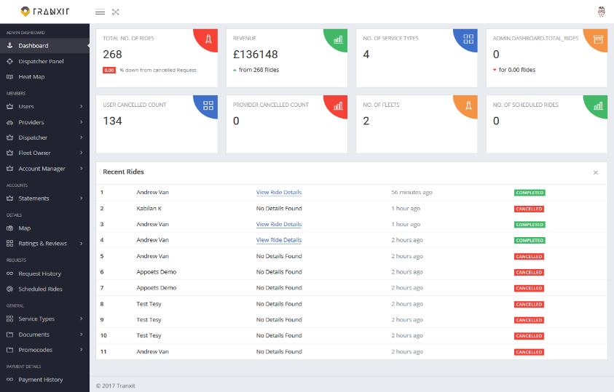

***Figure 3.12***

With the help of Uber's admin reporting system, it allows the driver to gain a deeper understanding by summarizing the driver’s performance, activities, and customer trends.

**Lyft**

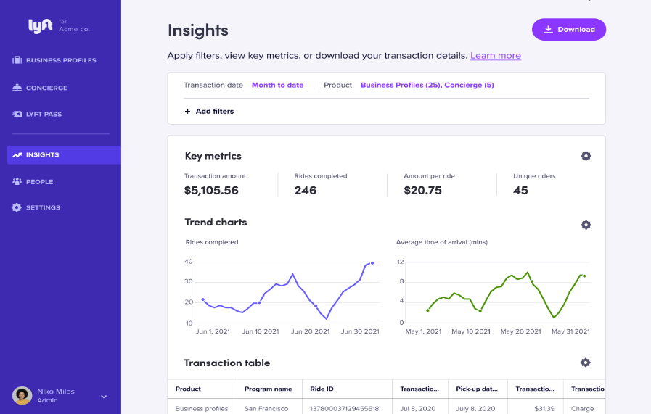

***Figure 3.13***

With the help of Lyft Admin and Reporting system, the administrators can monitor and manage the ridesharing ecosystem, receive insight into ride analytics, driver performance, and customer feedback, and enhance the Lyft experience.

**Grab**

**Grab**

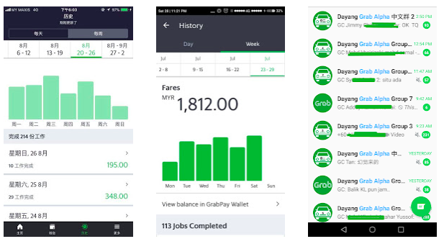

***Figure 3.14***

The Grab administrative report tracks and examine important performance data, such as finished reservations, driver earnings, client feedback, and market trends.

**Food Panda**

***Figure 3.15***

Food Panda admin and reporting system, generates detailed reports and utilize data visualization tools to identify popular cuisines, customer preferences, and areas for improvement.

***2.3 Identify / list all needed relations and the attributes in each relation1.User***

|  |  |  |  |  |
| --- | --- | --- | --- | --- |
| userID | userName | userContactNo | registeredDate | userStatus |
|  |  |  |  |  |

2.Driver

|  |  |  |  |  |
| --- | --- | --- | --- | --- |
| driverID | driverName | driverContactNo | driverRating | driverVehicle |
|  |  |  |  |  |

3.Feedback

|  |  |  |  |
| --- | --- | --- | --- |
| feedbackID | date | time | Comment |
|  |  |  |  |

4.Promotion

|  |  |  |  |  |  |
| --- | --- | --- | --- | --- | --- |
| promoCode | promoTitle | promoType | discountAmount | promoExpiryDate | promoStatus |
|  |  |  |  |  |  |

5.Service

|  |  |  |  |
| --- | --- | --- | --- |
| serviceTypeID | serviceTypeName | auditLog | costBaseline |
|  |  |  |  |

6.Shop

|  |  |  |  |  |
| --- | --- | --- | --- | --- |
| shopID | addressNo | street | city | postcode |
|  |  |  |  |  |

7.VehicleForRent

|  |  |  |  |  |  |  |
| --- | --- | --- | --- | --- | --- | --- |
| vehicleID | carPlateNo | carBrand | carModel | carType | carColour | pax |
|  |  |  |  |  |  |  |

8.Transport Service

|  |  |  |  |  |  |  |
| --- | --- | --- | --- | --- | --- | --- |
| tReceiptNo | serviceTypeID | pickUpLocation | dropOffLocation | date | pickUpTime | dropOffTime |
|  |  |  |  |  |  |  |

9.Delivery Service

|  |  |  |  |  |  |  |  |
| --- | --- | --- | --- | --- | --- | --- | --- |
| dReceiptNo | serviceTypeID | shopID | dropOffLocation | deliverDate | deliveryTime | arrivedDate | aririvedTime |
|  |  |  |  |  |  |  |  |

10.Rent Service

|  |  |  |  |  |  |  |
| --- | --- | --- | --- | --- | --- | --- |
| rentID | serviceTypeID | vehicleID | rentDateFrom | rentDateTo | rentTimeFrom | rentTimeTo |
|  |  |  |  |  |  |  |

11.Service Review

|  |  |  |  |  |
| --- | --- | --- | --- | --- |
| reviewID | serviceTypeID | date | time | comment |
|  |  |  |  |  |

12.Premium

|  |  |  |  |  |
| --- | --- | --- | --- | --- |
| eCardID | userID | premiumTier | memberSince | validTill |
|  |  |  |  |  |

13.Transaction Card

|  |  |  |  |
| --- | --- | --- | --- |
| cardNo | userID | IssuingBank | holderName |
|  |  |  |  |

14.User History

|  |  |  |  |  |  |
| --- | --- | --- | --- | --- | --- |
| userHistoryID | userID | previousTransaction | amountPaid | date | time |
|  |  |  |  |  |  |

15.Driver History

|  |  |  |  |  |  |
| --- | --- | --- | --- | --- | --- |
| driverHistoryID | driverID | previousOperations | amountReceived | date | time |
|  |  |  |  |  |  |

16.Transaction

|  |  |  |  |  |  |  |  |  |
| --- | --- | --- | --- | --- | --- | --- | --- | --- |
| transactionID | paymentStatus | userID | driverID | serviceTypeID | shopID | promoCode | feedbackID | price |
|  |  |  |  |  |  |  |  |  |

***3.0 Develop your database.***

***Figure 4.0***

1. User (userID, username, userContactNo, registeredDate,userStatus)

2. Driver (driverID, driverName, driverContactNo, driverRating, driverVehicle)

In Figure 1.1, we can see the Data Definition Language (DDL) code used to create our group's database named "Ppost." The database contains two tables, "User" and "Driver." The "User" table includes attributes such as userID (Primary Key), username, userContactNo, registeredDate, and userStatus. The "Driver" table includes attributes like driverID (Primary Key), driverName, driverContactNo, driverRating, and driverVehicle.

***Figure 4.1***

3. Feedback (feedbackID, date, time, comment)

4. Promotion (promocode, promoTitle, promoType, discountAmount, promoExpiryDate,promoStatus)

In Figure 1.2, two additional tables, "Feedback" and "Promotion," are created. The "Feedback" table includes attributes such as feedbackID (Primary Key), date, time, and comment. The "Promotion" table contains attributes like promocode (Primary Key), promoTitle, promoType, discountAmount, promoExpiryDate and promoStatus.

***Figure 4.2***

5. Service (serviceTypeID, serviceTypeName, auditLog, costBaseLine)

6. Shop (shopID, addressNo, street, city, postCode)

Moving on to Figure 1.3, we have two more tables, "Service" and "Shop," created within the "Ppost" database. The "Service" table includes attributes serviceTypeID (Primary Key), serviceTypeName, auditLog, and costBaseLine. The "Shop" table contains attributes like shopID (Primary Key), addressNo, street, city, and postCode.

***Figure 4.3***

7. VehicleForRent (vehicleID, carPlateNo, carBrand, carModel, carType, carColour, pax)

8. TransportService (tReceiptNo, serviceTypeID, pickUpLocation, dropOffLocation, date, pickUpTime, dropOffTime)

Figure 1.4 introduces two additional tables, "VehicleForRent" and "TransportService." The "VehicleForRent" table has attributes such as vehicleID (Primary Key), carPlateNo, carBrand, carModel, carType, carColour, and pax. In the "TransportService" table, a foreign key "serviceTypeID" is implemented to establish a relationship with the "Service" table. This table includes attributes like tReceiptNo (Primary Key), serviceTypeID (Foreign Key linking to the "Service" table), pickUpLocation, dropOffLocation, date, pickUpTime, and dropOffTime.

***Figure 4.4***

9. DeliveryService (dReceiptNo, serviceTypeID, shopID, dropOffLocation, deliverDate, deliverTime, arrivedDate, arrivedTime)

10. RentService (rentID, serviceTypeID, vehicleID, rentDateFrom, rentDateTo, rentTimeFrom, rentTimeTo)

11. ServiceRating (reviewID, serviceTypeID, date, time)

In Figure 1.5, three different tables are created. The "DeliveryService" table includes attributes such as dReceiptNo (Primary Key), serviceTypeID (Foreign Key for table Service), shopID (Foreign Key for table Shop), dropOffLocation, deliverDate, deliverTime, arrivedDate, and arrivedTime. The "RentService" table is connected to other tables via foreign keys and includes attributes like rentID (Primary Key), serviceTypeID (Foreign Key for table Service), vehicleID (Foreign Key for table VehicleForRent), rentDateFrom, rentDateTo, rentTimeFrom, and rentTimeTo. Lastly, the "ServiceRating" table includes attributes reviewID (Primary Key), serviceTypeID (Foreign Key for table Service), date, and time.

***Figure 4.5***

12. Premium (eCardID, userID, premiumTier, memberSince, validTill)

13. TransactionCard (cardNo, userID, issuingBank, holderName)

In Figure 1.6, two tables related to Users are displayed. The "Premium" table includes attributes eCardID (Primary Key), userID (Foreign Key for table User), premiumTier, memberSince, and validTill. The "TransactionCard" table includes attributes cardNo (Primary Key), userID (Foreign Key for table User), issuingBank, and holderName.

***Figure 4.6***

14. UserHistory (userHistoryID, userID, previousTransaction, amountPaid, date, time)

15. DriverHistory (driverHistoryID, driverID, previousOperation, amountReceived, date, time)

Figure 1.7 presents two more tables. The "UserHistory" table stores user-related historical data with attributes userHistoryID (Primary Key), userID (Foreign Key for table User), previousTransaction, amountPaid, date, and time. Similarly, the "DriverHistory" table stores historical data related to drivers, including attributes like driverHistoryID (Primary Key), driverID (Foreign Key for table Driver), previousOperation, amountReceived, date, and time.

***Figure 4.7***

16. Transaction (transactionID, paymentStatus, userID, driverID, serviceTypeID, shopID, promoCode, feedbackID, price)

Lastly, in Figure 1.8, the "Transaction" table is displayed, which has multiple foreign keys linking it to other tables in the "Ppost" database. This table includes attributes such as transactionID (Primary Key), paymentStatus, userID (Foreign Key for table User), driverID (Foreign Key for table Driver), serviceTypeID (Foreign Key for table Service), shopID (Foreign Key for table Shop), promoCode (Foreign Key for table Promotion), feedbackID (Foreign Key for table Feedback), and price.

|  |  |  |
| --- | --- | --- |
| Relation/Entity | Primary Key | Foreign Key |
| User (h) | {userID} | - |
| Driver (h) | {driverID} | - |
| Feedback (h) | {feedbackID} | - |
| Promotion (h) | {promoCode} | - |
| Service (h) | {serviceTypeID} | - |
| Shop (h) | {shopID} | - |
| VehicleForRent (h) | {vehicleID} | - |
| TransportService | {tReceiptNo} | {serviceTypeID} |
| DeliveryService | {dReceiptNo} | {serviceTypeID},  {shopID} |
| RentService | {rentID} | {serviceTypeID},  {vehicleID} |
| ServiceReview | {reviewID} | {serviceTypeID} |
| Premium | {eCardID} | {userID} |
| TransactionCard | {cardNo} | {userID} |
| UserHistory | {userHistoryID} | {userID} |
| DriverHistory | {driverHistoryID} | {driverID} |
| Transaction | {transactionID} | {userID},  {driverID},  {shopID},  {serviceTypeID},  {promoCode},  {feedbackID} |

***Figure 4.8 Overview***

*Figure 4.10*

*Figure 4.9* Ppost’s Logo

**References**

1.1 References:

<https://www.thinkautomation.com/histories/the-history-of-databases>

<https://statisticsanddata.org/the-most-popular-databases-2006-2020/>

<https://en.wikipedia.org/wiki/Database#Application>

<https://www.oracle.com/my/database/what-is-database/>

<https://en.wikipedia.org/wiki/Hierarchical_database_model>

https://en.wikipedia.org/wiki/Relational_database

https://en.wikipedia.org/wiki/Network_model

1.2 References:

<https://underscore.factor75.com/the-history-evolution-of-food-delivery/>

<https://itsourcecode.com/free-projects/database-design-projects/database-design-for-ordering-and-delivery-management-system/>

https://www.inettutor.com/diagrams/restaurant-food-delivery-system-free-database-design-tutorial/  
https://www.locate2u.com/articles/what-is-delivery-management-software/  
<https://elogii.com/blog/what-is-delivery-management-software/>

1.3 References:

<https://www.uber.com/us/en/about/?uclick_id=433ef8f7-5ec2-47c3-88b7-7a24d2f17a69>

<https://www.uber.com/us/en/about/uber-offerings/>

<https://www.businessinsider.com/uber-company-scandals-and-controversies-2017-11#march-2018-an-uber-self-driving-car-strikes-and-kills-elaine-herzberg-in-one-of-the-first-recorded-pedestrian-deaths-involving-an-autonomous-vehicle-43>

<https://en.wikipedia.org/wiki/Uber>  
<https://www.investopedia.com/articles/personal-finance/111015/story-uber.asp#toc-in-wake-of-scandals-kalanick-out-khosrowshahi-in>  
https://www.thestreet.com/technology/history-of-uber-15028611

2. Reference:

<https://en.wikipedia.org/wiki/Grab_(company)>

<https://www.questback.com/blog/feedback-culture-how-uber-mastered-the-feedback-loop/#:~:text=Uber%20creates%20an%20average%20rating,is%20let%20go%20from%20Uber>

<https://www.fedex.com/en-my/privacy-policy.html>

<https://chefsstage.com/uber-eat-promo-code/#:~:text=When%20you%20place%20an%20order,on%20the%20app%20or%20website>

<https://help.uber.com/riders/article/scheduling-a-ride-in-advance?nodeId=63165ec1-0910-409e-972f-0b8d8df1a605>

<https://support.airasia.com/s/article/airasia-ride-TH-How-far-you-can-make-advance-booking-on-airasia-ride?language=en_GB>

<https://www.uber.com/us/en/u/uber-rent/>

<https://ride.lyft.com/rentals?start=1684029600000&end=1684116000000>

<https://www.uber.com/us/en/u/uber-rent/>

<https://www.mcdonalds.com.my/mcdelivery-webpolicy>

<https://help.uber.com/ubereats/restaurants/article/how-does-the-delivery-charge-work-on-uber-eats?nodeId=7d8d6312-df92-4b67-a561-effc6b720359>

<https://www.tripsavvy.com/lyft-and-uber-which-rideshare-app-is-cheaper-4691771#:~:text=Surge%20Pricing&text=Surge%20and%20high%20traffic%20times,different%20price%20on%20each%20app>

4.References:

https://www.start.io/blog/who-is-ubers-target-market-uber-market-segments-analysis-marketing-strategy-competitors/ <https://gigworker.com/uber>black/#:~:text=Uber%20Black%20is%20a%20luxury%20vehicle%20service%20that,service%20into%20a%20convenient%2C%20yet%20equally%20glamorous%20ride. <https://www.uber.com/us/en/item-delivery/>

https://www.similarweb.com/website/ubereats.com/#geography

<https://www.g2.com/products/uber-freight/reviews>

<https://www.businessofapps.com/data/uber-eats-statistics/>

5. References

<https://www.uber.com/legal/nl/document/?country=united-states&lang=en&name=cookie-notice>